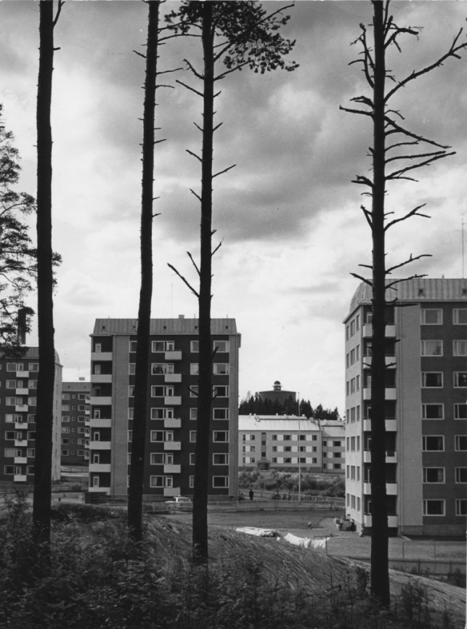
Tehtäviä:
1. Etsi rakennuksista eroavaisuuksia. Voit käyttää apuna rakennusinventointimonistetta.
2. Mikä kerrostaloissa on alkuperäistä, mikä uusittua?
3. Mikä rakennuksista on mielestäsi ”alkuperäisimmässä” asussa?
4. Käy ottamassa valokuva samasta paikasta mistä viereinen 1960-luvun kuva on otettu.

-----------------------------------------------------------------------------------------------------------------------------------------------
Tehtäviä:
1. Etsi rakennuksista eroavaisuuksia. Voit käyttää apuna rakennusinventointimonistetta.
2. Mikä kerrostaloissa on alkuperäistä, mikä uusittua?
3. Mikä rakennuksista on mielestäsi ”alkuperäisimmässä” asussa?
4. Käy ottamassa valokuva samasta paikasta mistä viereinen 1960-luvun kuva on otettu.

